**Changes to hma-pwl-production-v3.2**

General

* Import macro updated to support worksheet version V3.2 (3-20-2025).
* Header panes have been frozen so that context is maintained while scrolling.
* Update PWL Production Spreadsheet instructions to 2025 Edition.

Core Density Analysis

* Fixed a bug that caused the Lot Length (column A) to not count overflow sublots. Did not affect pay.

LJ Nuc Density F&t

* Added footprint test fields.

Gmm F&t / Gmb F&t / AC% / Volumetric Pay Factors

* Comments fields have been added. For the Gmm and Gmb worksheets, the comments section is available on the far-right side of the worksheet in column CS. For the AC% worksheet, the comment section is available on the far-right side of the worksheet in column CX.
* Lot Size (tons) will now only sum the tonnage from sublots that contain QC test results. This way if a QC test is missed during production, the tonnage can still be tracked with the worksheet without affecting pay.
  + NOTE: A QC test result is required for the Gmm, Gmb, and AC for the sublot tonnage to be counted towards the lot.

Volumetric Pay Factors

* Fixed a bug that would incorrectly assess the BTS Referee Testing Fee when the pay factor increased as a result of the referee testing. Affects pay (in very rare instances).

Total Pay Adjustment Summary

* Fix header for Project Limits which previously would only show the beginning station in decimal format. Now it will show the range in station format.

Volumetric Charts

* Changed the representation of the Upper and Lower Spec Limit (Va USL and Va LSL) for the Air Voids chart to an orange dashed line (previously solid green line) to better differentiate specification limits from action limits.
  + Limits will conform to the following representation standards:
    - Solid Red Lines = Acceptance Limits
    - Solid Green Lines = Action Limits
    - Dashed Orange Lines = Specification Limits

(NEW) Daily Average Gmm for Density

* As you enter the volumetric test results, this new worksheet will automatically calculate the Daily Average Gmms according to MOTP WTM T355 section 10.1.1 that will be used for final acceptance and pay adjustment.
* The Gmms in this table can be entered into the HMA Field Density Worksheet (V2.2+) to adjust the results for pay. The adjusted density results can then be copied back into the HMA PWL Production Nuc Density F&t and/or LJ Nuc Density F&t worksheets to determine pay.

**Additional Guidance for Enabling Macros in Microsoft Excel**

As of February 23, 2023, Microsoft has blocked macros by default from spreadsheets downloaded from the internet (aka Pantry) to provide additional protection from malicious macros. When this occurs, you will see an error like this at the top of the spreadsheet:



When this error is presented, you will be unable to enable macros using old methods where you could simply click the button in the banner to enable macros. Additional steps are required to enable the macros. Please perform the following steps to enable macros:

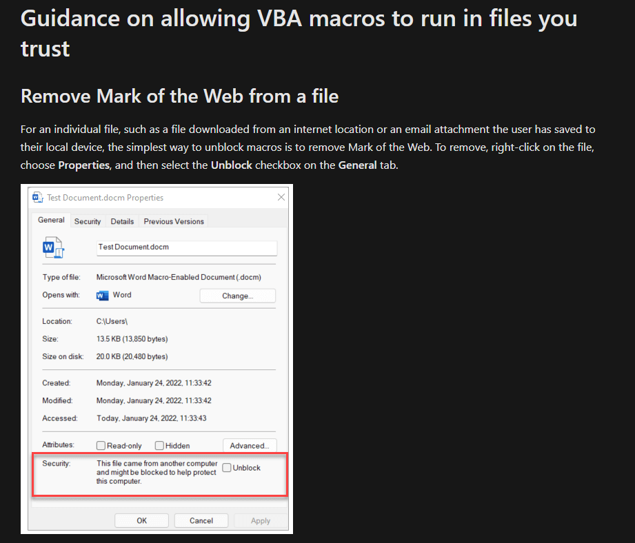

Additional information about this change can be found on Microsoft’s website at:

<https://learn.microsoft.com/en-us/deployoffice/security/internet-macros-blocked>

If you have any additional questions or issues running macros in your worksheets, please reach out to:

[albert.kilger@dot.wi.gov](mailto:albert.kilger@dot.wi.gov)